**Selenium IDE Download and Installation**

For the ease of understanding, I have bifurcated the entire IDE installation process in the following chunks/steps.

Before taking off, there is one thing that needs to be in place prior to the installation; Mozilla Nightly Browser. You can download it from here =>[Mozilla Nightly Browser download](http://www.mozilla.org/en-US/).

**Step #1:** **Selenium IDE download**: Open the browser (Nightly Browser) and enter the URL – [http://seleniumhq.org/](http://www.seleniumhq.org/) . This would open the official Selenium head quarter website. Navigate to the “Download” page; this page embodies all the latest releases of all the selenium components. Refer the following figure.

[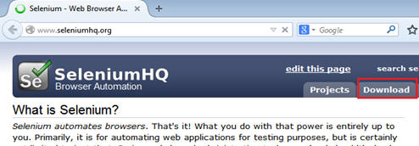](http://cdn.softwaretestinghelp.com/wp-content/qa/uploads/2014/10/Selenium-IDE-1.jpg)

**Step #2:** Move under the selenium IDE head and click on the link present. This link represents the latest version of the tool in the repository. Refer the following figure.

**Step #3:** As soon as we click on the above link, a security alert box would appear so as to safeguard our system against potential risks. As we are downloading the plug-in from the authentic website, thus click on the “Allow” button. 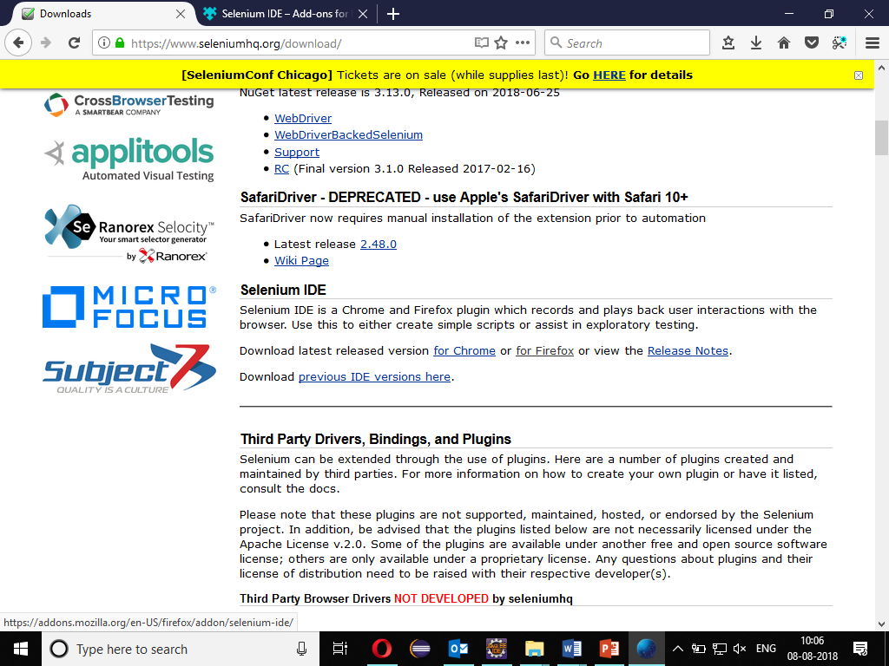

**Step #4:** Now Nightly Browser downloads the plug-in in the backdrop. As soon as the process completes, software installation window appears. Now click on the “Add o Firefox” button. 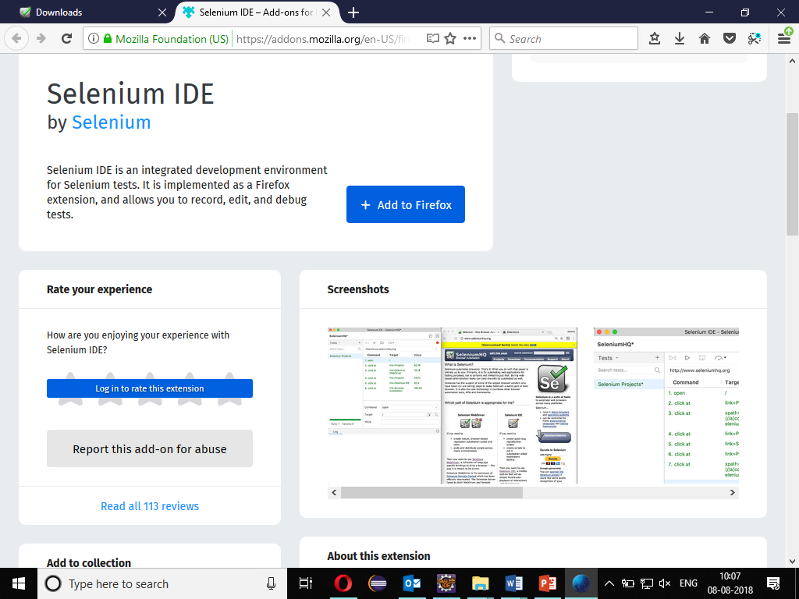

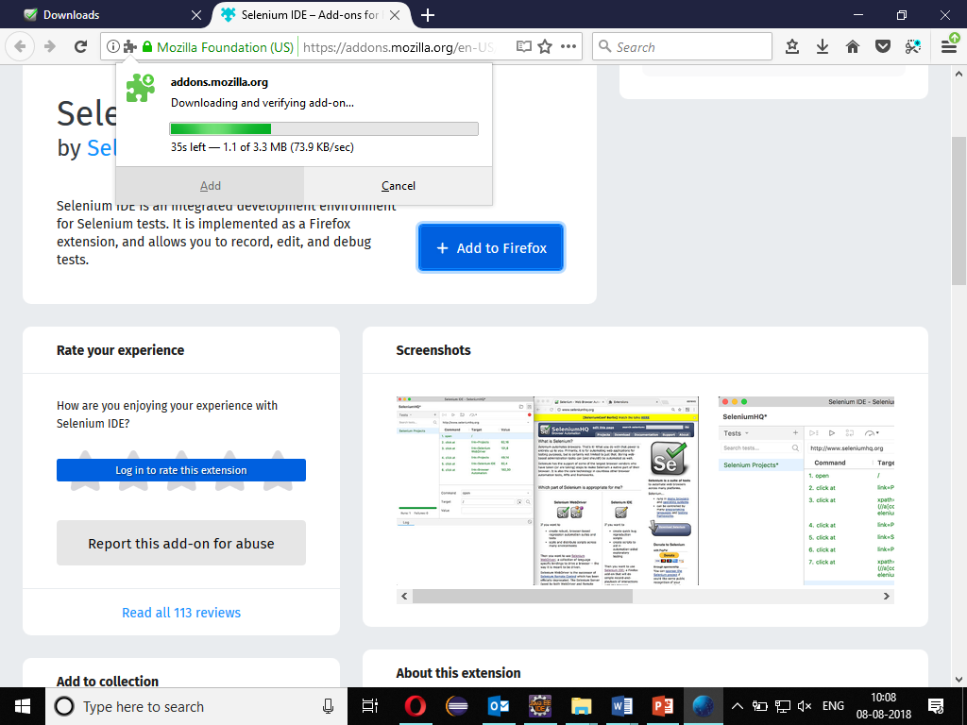

**Step #5:** After the installation is completed re-start the Nightly Browser.

**Step #6:** Once the Nightly Browser is booted and started again, we can see selenium IDE indexed under menu bar -> Web Developer -> Selenium IDE.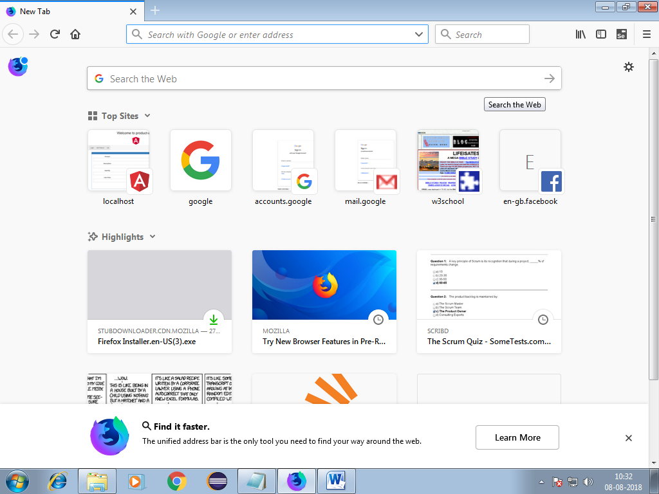

**Step #7:** .You will get Selenium In window

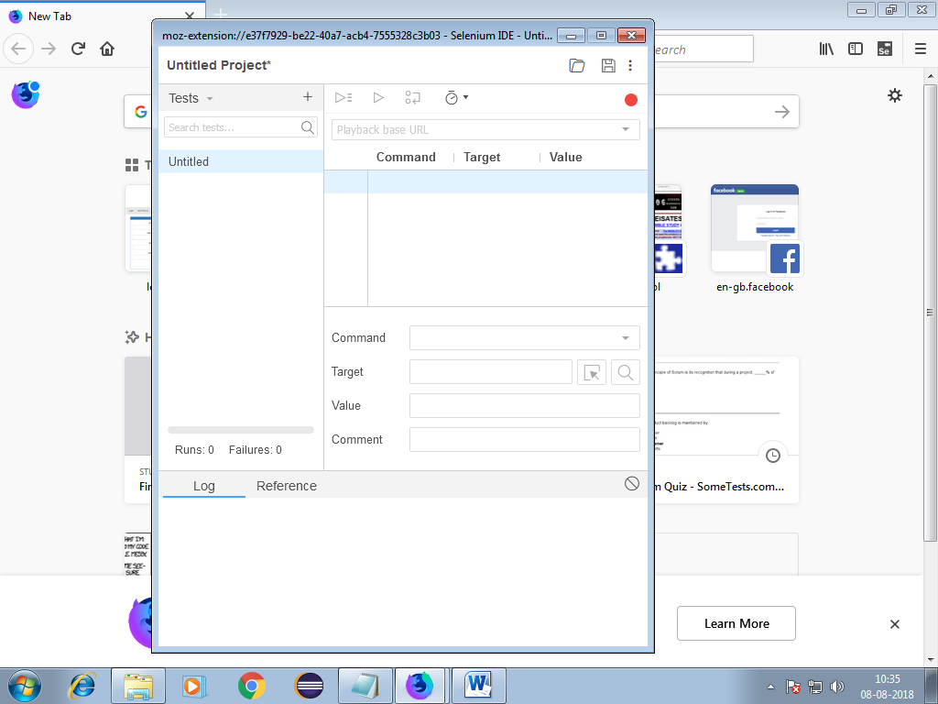

**Step #8:** Click on + button beside Tets option and give name of your test (Suppose Gmai_test) and click on add

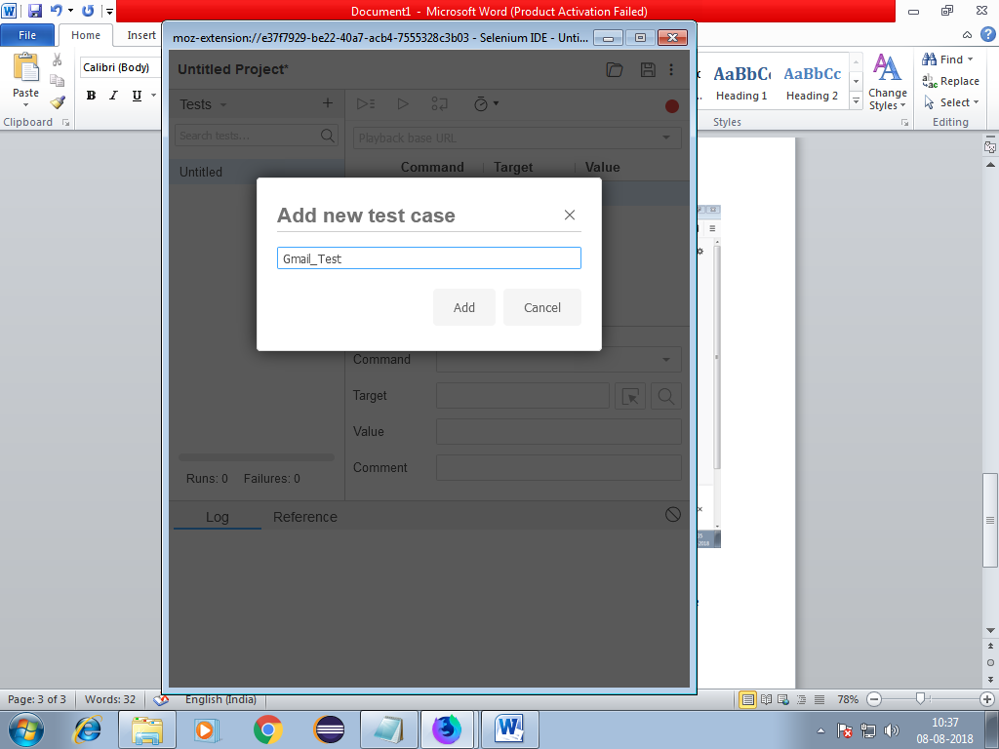

**Step #9:** Give Url (<http://account.google.com>) and click on start recording

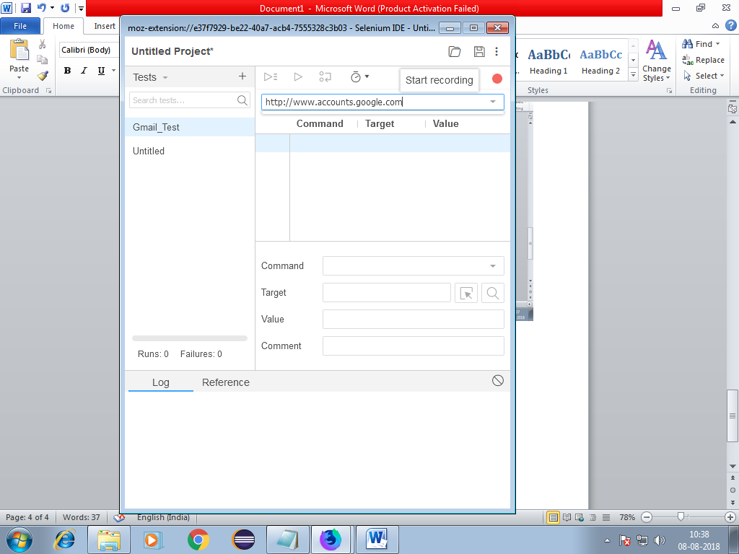

**Step #10:** .Open browser and type same url

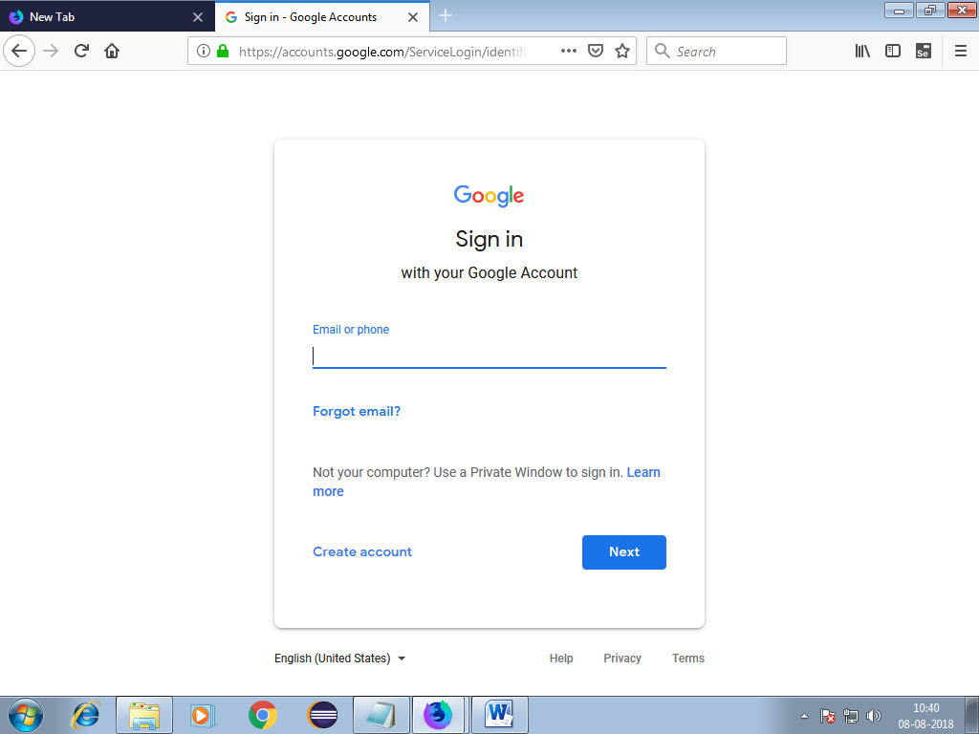

**Step #11:** Enter mail id and see the recording in Selenium id

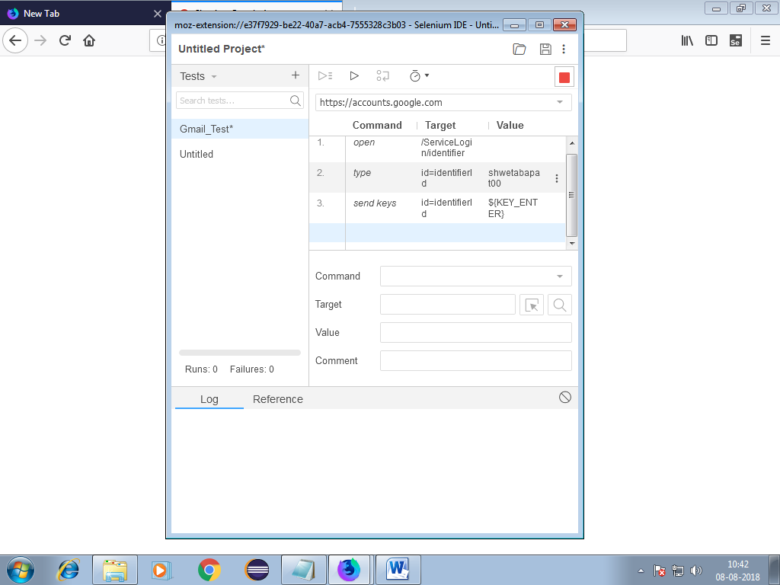

**Step #12:** .Now run the test

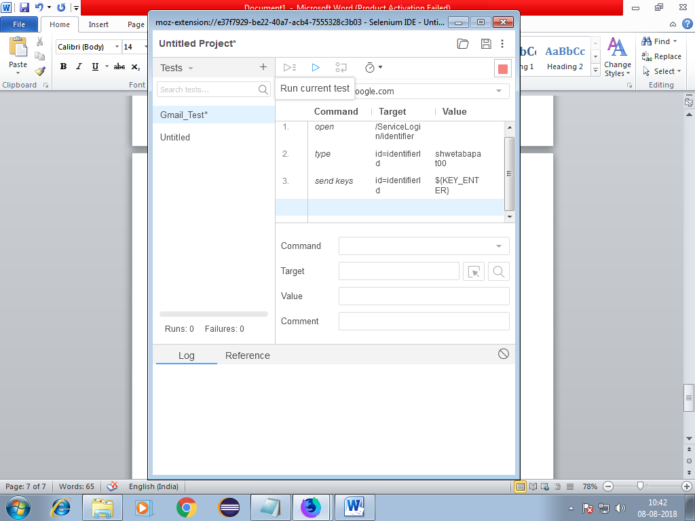

**Step #13:** .You will get playback sometimes ,so click on playback

Your test will run and output will be displayed as shown below.

